

**DEPARTMENT OF COMPUTER SCIENCE AND ENGINEERING**

**PROJECT TITLE**

***Image Recognition with IBM Cloud Visual Recognition***

College code:1103

**Sunitha S**

3rd yr, 5th sem

Reg no.:110321104050

[Sunitha.sappanisss@gmail.com](mailto:Sunitha.sappanisss@gmail.com)

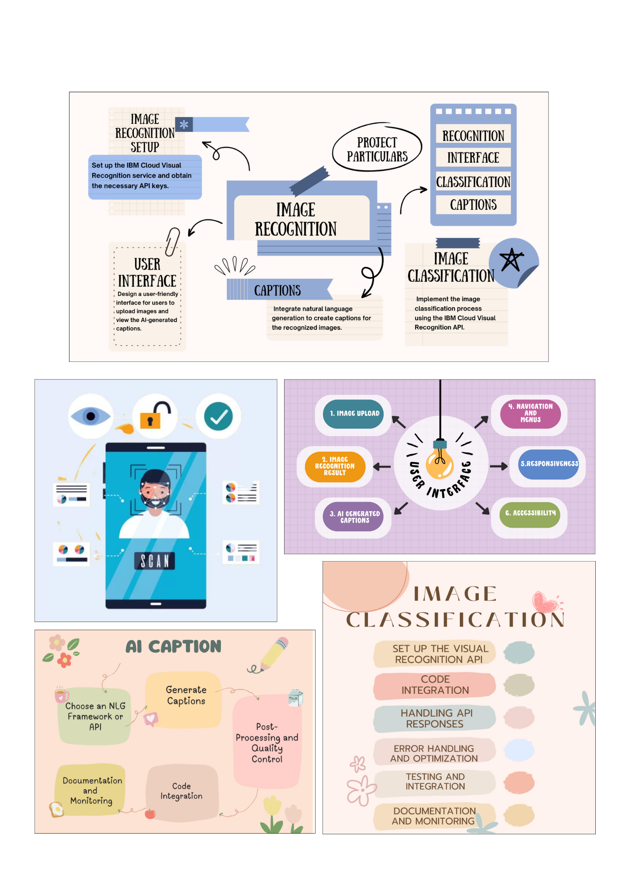**PROJECT DESIGNING AND THINKING**

**ALGORITHM**

**1.Image recognition configuration:**

1. **Register for an IBM Cloud account:**

Sign up for an IBM Cloud account, which serves as a basis for accessing cloud-based services.

1. **Create an instance of the IBM Cloud Image Recognition service:**

Configure a dedicated instance of the image recognition service, creating a space where image data will be processed.

1. **Get API key and credentials:**

API keys and secure credentials are provided by IBM Cloud to authenticate and authorize your application to access the Image Recognition service.

1. **Store API keys securely:**

Secure API keys and credentials to protect against unauthorized access to your services and data.

**2.User interface:**

1. **Design wireframes and mockups for the user interface:**

Create visual representations of your interface layout and structure to plan the arrangement of elements.

1. **Implement a responsive and user-friendly interface:**

Develop a design that adapts perfectly to different devices and screen sizes while prioritizing usability.

1. **Create photo upload page:**

Design a dedicated page where users can select and upload images, making the process intuitive and simple.

1. **View AI-generated recognition and annotation results:**

Presents AI-generated recognition and annotation results in a format that is visually appealing and easy to make out for stoner.

1. **Add social sharing button:**

co-opt buttons that allow users to easily share recognized images and captions on social media platforms.

1. **Implement user interaction features:**

amplify interactive elements like comments, likes, and the ability to save images to engage users and foster a sense of community.

**3.Image classification:**

1. **Retrieve the API key and endpoint for the visual recognition service:**

Collect the necessary credentials to securely access the Eye Recognition service.

1. **Choose an image to be classified**:

Select the image that needs classification.

1. **Make an API request to the visual recognition service:**

Send an HTTP request to the service, including the selected image, to start the classification process.

1. **Receive and process API responses containing identification results:**

Collects the results returned by the service, including objects, scenes, and concepts recognized in the image.

**4.AI-generated captions:**

1. **Choose NLG solution (e.g.GPT-3, spaCy):**

Choose a natural language generation solution or framework for captioning.

1. **Get the results of image classification recognition:**

Collect information obtained from the image classification process.

1. **Create annotation templates:**

Establish templates or structures to guide the NLG model in generating consistent annotations.

1. **Use NLG solution to create subtitles:**

Use NLG solutions to create descriptive and contextual annotations based on recognition results.

1. **Tweak and filter captions for quality control:**

Review and improve generated subtitles to ensure they are grammatically correct, consistent, and engaging, while filtering out low-quality content.

**5.User Commitment:**

1. **Design an image library for users to organize and introduce their images:**

Create visually appealing galleries where users can organize and display their images.

1. **Implement social sharing functionality for recognized images and captions:**

Allow users to easily share recognized images and captions on their favorite social media platforms.

1. **Expanded options for users to save images and captions to profiles:**

Provides the ability for users to save and organize their favorite images and related captions.

1. **Enable user-generated content features like comments and likes:**

Drive user engagement and engagement by allowing users to comment and express appreciation for shared content.

**PLATFORM AND COMMUNICATION PLATFORMS:**

**Communication:** IBM Cloud

**Programming language:**

1.HTML, CSS, Javscript

2.Python

3.NLG Framework/API

4.Additional server-side languages

If our project requires server-side components or APIs beyond visual recognition and NLG components, we shall choose a server-side language based on your familiarity and requirements. Specific requirements of these components. Popular choices include Node.js, Ruby, and PHP. By combining HTML, CSS, and JavaScript for the user interface with Python for image classification and NLG integration, you can create a comprehensive and interactive image recognition platform. IBM Cloud will serve as the storage and cloud infrastructure for your project, providing scalability and accessibility to users across a variety of devices.